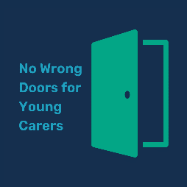
“No Wrong Doors for Young Carers” – Suggested ‘to-do list’
This tool provides a list of suggested actions which can help implement “No Wrong Doors for Young Carers”. Please use the space at the bottom to add your own actions based on your local priorities/context
Action | Who? | When?
Ensure young carers, young adult carers and the “No Wrong Doors for Young Carers” MoU and the legal duties are reflected in Carers Strategy and Integrated Care Strategy
Ensure the voices of young carers and young adult carers and local young carer support services are being heard in local carer involvement initiatives and wider ICS strategic development.
Create/refresh a local plan for proactively promoting carer, and young carer-friendly communities
Set up multi-agency Young Carer strategic group/No Wrong Doors implementation group
Review Young Carers Needs Assessments and Transitions Assessments processes, paperwork and practice to ensure they reflect legal requirements
Create/update referral pathway to ensure that there is access to information, assessment and preventative support from all parts of the system, including from the NHS and mental health services and the voluntary sector
Review care needs/adult carer/other health assessments to ensure they ask about children and whether children have caring responsibilities
Implement programme of awareness-training for adult social care/health professionals
Agree on audit/review process for No Wrong Doors for Young Carers implementation
Liaise with hospital trust(s) (including mental health inpatient units) to ensure they are aware of duty to consult young carers around hospital discharge
Share YCNV’s suggested wording for mental health service paperwork with local mental health trust (for both Adult Mental Health services and CAMHS)
Review commissioning of relevant services to identify opportunities to include young carers
Explore opportunities for provision of whole-family support for young carers
Liaise with Family Hub to ensure they are aware of young carers
Develop a data-sharing agreement to improve information-sharing across health, social care, education and voluntary sector
Review use of SNOMED codes in relation to young carers and young adult carers across Primary Care
Review specifications for commissioner carer support (young carers, young adult carers, adult carers) in light of the “No Wrong Doors for Young Carers” MoU and guidance
Explore opportunities for improving data-sharing between children’s and adult services
Review information on council/ICS websites in relation to young carers and young adult carers (including information for young adult carers as to how adult services differs from children’s services)
Actively engage with and promote Young Carers Action Day
Link in with any preventative services for children and their families, including Early Help to ensure they recognise the need for identification and support for young carers
Action | Who? | When?

